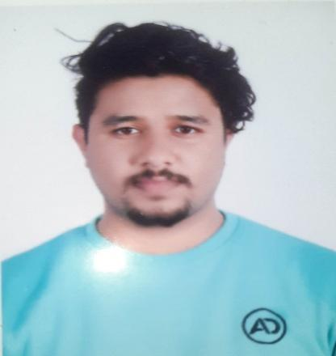

**Saugat Bhandari**

Instructor with good communication skills and ability to work well in new environments. Good temperament when it comes to learning and growing personal skills. Good ability to learn quickly on the job.

**Work History**

2022/12 – Instructor

2023/10 *Informatics Consultancy, Kathmandu*

* Applied various teaching aids to minimize learning gaps and instruct and motivate students.
* Evaluated and revised lesson plans and course content to achieve student-centered learning.
* Tracked student progress, frequently checking in with struggling students and identifying root causes of problems.
* Optimized learning plans based on student performance and feedback.

**Education**

2017/06 – +2 Computer Science

2019/08 *Global College Of Management – Mid Baneshwor, Kathmandu*

* CGPA 3.03

2019/11 – Bachelor in Computer Application

Current Dhobighat, Lalitpur, Nepal

* I have maintained a good GPA score
* I have passed all of my finals with a good score

**Skills**

Learner Assessment – Very Good

Student Engagement

English Language – Expert

Web Development – Good

Communication – Good

Team Work – Very Good

Programming Languages (C, Python, Java)

MySql

**Contact**

Address

Minbhawan, Kathmandu

Phone

9866299111

Email

bhandarisaugat56@gmail.com